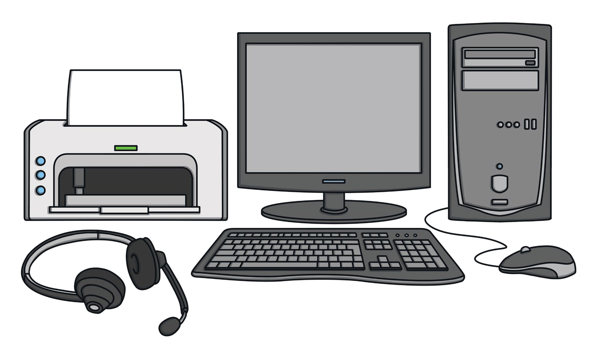
Word Bank headphones keyboard monitor mouse printer

